PROGRAM 3 / CandyLife Game

CSC 1300 / SPRING 2023

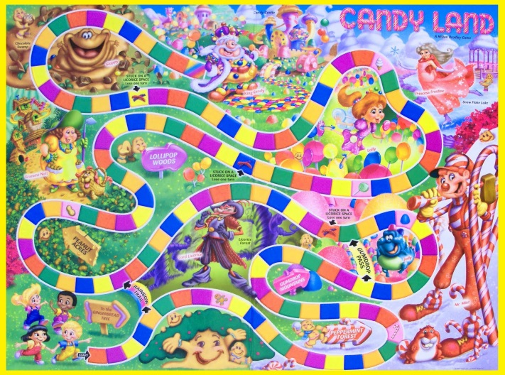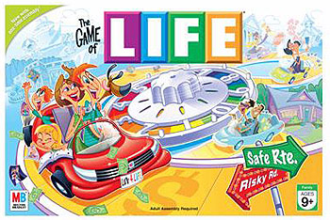

# Important Dates

**Assignment Date:** Wednesday, March 8, 2023

**Due Date:** Wednesday, April 5, 2023 by 11:59pm

**May be turned in late up through April 10, 2023 11:59pm at a grade reduction of 10 points off per day late.**

# Submission

You should have a zip file named **username_prog3**. This zip file should contain the files listed below. Replace “username” with your TTU username.

* **username_prog3driver.cpp** (contains main function)
* **username_prog3functions.cpp** (contains all programmer defined functions)
* **username_prog3.h** (header file for program containing #includes <>, namespace, function prototypes, and any global constant variables)
* **goodactions.txt** (contains 20 good things that could happen)
* **badactions.txt** (contains 20 bad things that could happen)

# Description

## Overall Game Play

Create a game that is a mixture between the games Candyland and Life. There can be up to **20 players** play the game at one time. There is an imaginary game board that has **25 spaces**. Players should be able to progress through the spaces on the board with die rolls. Each die roll will move the player forward that many spaces. Each “space” on the board makes something either good or bad happen to the player. Players can also either win or lose money on each space.

The game ends when a player lands on or goes past the last space on the board.

## Game Setup

Each player begins the game with **zero** money in their account

Each player begins the game on board-space **zero**.

## Player Turns

Each player has a turn where all they do is roll a dice.

When a player lands on a space, something good or bad is selected **randomly**.

If it is a good action, then a good action happens to the player, a smiley face is printed, and money is added to their account.

If it is a bad action, then a bad action happens to the player, a frown face is printed, and money is subtracted from their account.

# Constant Variables

* Maximum Number of Players possible: 20
* Number of Spaces on Board: 25

# Specifications

* You will have three arrays:
  + names – will hold the names of players playing the game. Example: names[0] could hold April Crockett and names[1] could hold Jason Crockett if April & Jason are currently playing the game.
  + boardSpace – will hold the current location (space) of players playing the game. Example: boardSpace[0] could hold 15 and boardSpace[2] could hold 6 if April was currently at space 15 on the board and Jason was currently at space 6 on the board.
  + money –will hold how much money each player has playing the game. Example: money[0] could hold 50000 and money[1] could hold -4000 if April currently had $50,000 and Jason had -$4,000 (people can have a negative balance in the game!)
* You will allow your players to play the game as many times as they want
* You can name your imaginary land whatever you want. (I called mine Goodbadland)
* You will create two text files – **badactions.txt** and **goodactions.txt**.   
  (There are more details on this later in this document.)

# Functions

## Main Function

* Print out the name of your imaginary land/game.
* Get the number of players from the user.   
  Validate that they entered a number between 1 and the maximum number of players (inclusively).
* Set up your arrays for the start of the game. Do NOT define arrays inside any loops! Array size should be the global constant for maximum number of players.
  + Set each element of names array to an empty string,
  + Set each element of boardSpace array to zero, and
  + Set each element of money array to 0.0.
* Call the **GetPlayersNames**() function
* Create a loop that will iterate until one of the players has reached the last space on the board.
* Create another loop to iterate through each of the players for each turn. For each player’s turn, you will:  
  + Call the **RollDice**() function
  + Add the dice number to the position in the boardSpace array that corresponds to the current player.
  + If they have reached the end of the board, then call the **PlayerFinishedBoard**() function. Note: this means that once a player reaches the end, they do not activate the action on that space. No good or bad action should be printed and no money should be added or subtracted from this player.
  + If they have not reached the board, then call the **ActivateActionOnSpace**() function.
* After a player reached the ending space on the board and the results have all been printed, then ask the user if they want to play again.

## getPlayerNames Function

**Parameters:** string array (containing player’s names), and an integer holding the number of players that want to play

**Return data:** none

Get each player’s name and place their name in each element of the names array. Notice when the player’s names are printed out in the sample output. Your program should print out the player’s names in the same way.

## rollDice() Function

**Parameters:** a string, holding the current player’s name

**Return data:** integer, with the dice number rolled

Print out the player’s name and tell them to press enter to roll die.

Randomly generate a number between 1 & 6 (for the dice roll)

Print a cool picture of the dice that was rolled (code given to you in **dice.cpp)**

## PlayerFinishedBoard Function

**Parameters**: all the arrays, the number of players

**Return data**: none

This code should execute when one of the players reached the last space on the board. It will display the results of the game – who reached the end of the board and also who ended up with the most money.

* Use a for loop to iterate through the boardSpace array and find the player who reached the highest board space. Save this player’s name.
* Print out the player who had the highest board space.
* Use a for loop to iterate through the money array and find the player who had the most money at the end of the game. Save this player’s name.
* Print out the player who had the most money.

## ActivateActionOnSpace Function

**Parameters**: all the arrays, the number of players, the integer index of the current player

**Return data**: none

Print out their current board space and then display what happens on the space – good action or bad action.

There are two text (.txt) files containing the text of what happens. You will have to create each text file by opening vscode or another text editor and manually typing them. The **goodactions.txt** text file should contain 20 good things (in all capital letters) that can happen to the player. An example from my file is “YOU BEAT YOUR HIGH SCORE PLAYING TETRIS.” The **badactions.txt** text file should contain 20 bad things that can happen to the player. An example from my file is “YOU GOT ABDUCTED BY ALIENS WHO TURNED YOU IN TO A LLAMA.”

* First, randomly generate either a 1 or 2.   
  **1 will represent a good action** happening and **2 will represent a bad action** happening.
* If good, then…
  + Open the **goodactions.txt** file
  + Print out a big smiley face (doesn’t have to look exactly like mine but it has to be happy)
  + Print the word “GREAT!“ (or something similar)
* If bad, then…
  + Open the **badactions.txt** file
  + Print out a big frowny face (doesn’t have to look exactly like mine but it has to be sad)
  + Print the word “OH NO!“ (or something similar)
* Then randomly generate a number between 1 & 20.
* Use a for loop that iterates the number of times that was randomly generated in the step above.
  + In the for loop, read in a line from the file using getline.
* After the for loop, print out the line from the file
* Then, randomly generate a number between 1 & 100,000.
  + If it was a good action, then **add** this randomly generated amount to this player’s money   
    (in the money array).
  + If it was a bad action, then **subtract** this randomly generated amount to this player’s money   
    (in the money array).
* Print out to the screen how much money this player has now in their account.

# OUTPUT

## SAMPLE TEXT FILE – goodactions.txt

I have provided a **sample** goodactions.txt file so you can see what it looks like but **you must write your own** 20 “good” actions of things that could happen in your game that would be considered good fortune for your player.

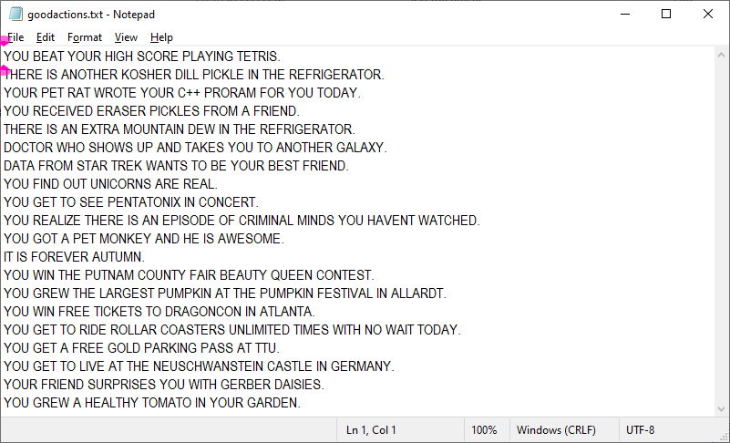

## SAMPLE TEXT FILE – badactions.txt

I have provided a sample badactions.txt file so you can see what it looks like but **you must write your own** 20 “bad” actions of things that could happen in your game that would be considered bad fortune for your player.

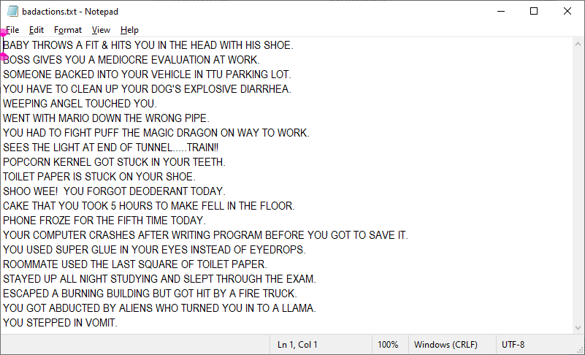

## SAMPLE OUTPUT OF PROGRAM RUNNING

User input is highlighted in yellow.

**YOU ARE PLAYING GOODBADLAND!**

**How many players? 2**

**PLAYER 1, WHAT IS YOUR NAME?**

**NAME: Bammalamma Jamjam**

User pressed ‘Enter’ key before “YOU ROLLED A 1.” appeared.

**PLAYER 2, WHAT IS YOUR NAME?**

**NAME: Grape Ape**

**----------**

**Bammalamma Jamjam, PRESS ENTER TO ROLL DIE.**

**YOU ROLLED A 1.**

**_________**

**| |**

**| o |**

**| |**

**|_________|**

**Bammalamma Jamjam IS NOW ON SPACE 1**

**- -**

**' |**

**-----------**

**/ \**

**/ \**

**OH NO! WENT WITH MARIO DOWN THE WRONG PIPE.**

**SUBTRACTED $16147.00 FROM YOUR ACCOUNT.**

User pressed ‘Enter’ key

**YOU NOW HAVE $-16147.00 IN YOUR ACCOUNT.**

**----------**

**----------**

**Grape Ape, PRESS ENTER TO ROLL DIE.**

**YOU ROLLED A 2.**

**_________**

**| |**

**| o |**

**| o |**

**|_________|**

**Grape Ape IS NOW ON SPACE 2**

**- -**

**' |**

**-----------**

**/ \**

**/ \**

**OH NO! WEEPING ANGEL TOUCHED YOU.**

**SUBTRACTED $24050.00 FROM YOUR ACCOUNT.**

User pressed ‘Enter’ key

**YOU NOW HAVE $-24050.00 IN YOUR ACCOUNT.**

**----------**

**----------**

**Bammalamma Jamjam, PRESS ENTER TO ROLL DIE.**

**YOU ROLLED A 2.**

**_________**

**| |**

**| o |**

**| o |**

**|_________|**

**Bammalamma Jamjam IS NOW ON SPACE 3**

**\* \***

**|**

**\ /**

**\ /**

**-----------**

**GREAT! YOU GET TO RIDE ROLLAR COASTERS UNLIMITED TIMES WITH NO WAIT TODAY.**

**ADDED $7279.00 TO YOUR ACCOUNT.**

**YOU NOW HAVE $-8868.00 IN YOUR ACCOUNT.**

User pressed ‘Enter’ key

**----------**

**----------**

**Grape Ape, PRESS ENTER TO ROLL DIE.**

**YOU ROLLED A 4.**

**_________**

**| o o |**

**| |**

**| o o |**

**|_________|**

**Grape Ape IS NOW ON SPACE 6**

**\* \***

**|**

**\ /**

**\ /**

**-----------**

**GREAT! YOU GREW THE LARGEST PUMPKIN AT THE PUMPKIN FESTIVAL IN ALLARDT.**

**ADDED $10811.00 TO YOUR ACCOUNT.**

**YOU NOW HAVE $-13239.00 IN YOUR ACCOUNT.**

User pressed ‘Enter’ key

**----------**

**----------**

**Bammalamma Jamjam, PRESS ENTER TO ROLL DIE.**

**YOU ROLLED A 4.**

**_________**

**| o o |**

**| |**

**| o o |**

**|_________|**

**Bammalamma Jamjam IS NOW ON SPACE 7**

**\* \***

**|**

**\ /**

**\ /**

**-----------**

**GREAT! YOU GET TO SEE PENTATONIX IN CONCERT.**

**ADDED $26582.00 TO YOUR ACCOUNT.**

User pressed ‘Enter’ key

**YOU NOW HAVE $17714.00 IN YOUR ACCOUNT.**

**----------**

**----------**

**Grape Ape, PRESS ENTER TO ROLL DIE.**

**YOU ROLLED A 3.**

**_________**

**| o |**

**| o |**

**| o |**

**|_________|**

**Grape Ape IS NOW ON SPACE 9**

**- -**

**' |**

**-----------**

**/ \**

**/ \**

**OH NO! PHONE FROZE FOR THE FIFTH TIME TODAY.**

**SUBTRACTED $2734.00 FROM YOUR ACCOUNT.**

**YOU NOW HAVE $-15973.00 IN YOUR ACCOUNT.**

User pressed ‘Enter’ key

**----------**

**----------**

**Bammalamma Jamjam, PRESS ENTER TO ROLL DIE.**

**YOU ROLLED A 3.**

**_________**

**| o |**

**| o |**

**| o |**

**|_________|**

**Bammalamma Jamjam IS NOW ON SPACE 10**

**\* \***

**|**

**\ /**

**\ /**

**-----------**

**GREAT! YOU FIND OUT UNICORNS ARE REAL.**

**ADDED $19595.00 TO YOUR ACCOUNT.**

User pressed ‘Enter’ key

**YOU NOW HAVE $37309.00 IN YOUR ACCOUNT.**

**----------**

**----------**

**Grape Ape, PRESS ENTER TO ROLL DIE.**

**YOU ROLLED A 3.**

**_________**

**| o |**

**| o |**

**| o |**

**|_________|**

**Grape Ape IS NOW ON SPACE 12**

**\* \***

**|**

**\ /**

**\ /**

**-----------**

**GREAT! DOCTOR WHO SHOWS UP AND TAKES YOU TO ANOTHER GALAXY.**

**ADDED $10794.00 TO YOUR ACCOUNT.**

**YOU NOW HAVE $-5179.00 IN YOUR ACCOUNT.**

User pressed ‘Enter’ key

**----------**

**----------**

**Bammalamma Jamjam, PRESS ENTER TO ROLL DIE.**

**YOU ROLLED A 6.**

**_________**

**| o o |**

**| o o |**

**| o o |**

**|_________|**

**Bammalamma Jamjam IS NOW ON SPACE 16**

**- -**

**' |**

**-----------**

**/ \**

**/ \**

**OH NO! SOMEONE BACKED INTO YOUR VEHICLE IN TTU PARKING LOT.**

**SUBTRACTED $29992.00 FROM YOUR ACCOUNT.**

**YOU NOW HAVE $7317.00 IN YOUR ACCOUNT.**

User pressed ‘Enter’ key

**----------**

**----------**

**Grape Ape, PRESS ENTER TO ROLL DIE.**

**YOU ROLLED A 3.**

**_________**

**| o |**

**| o |**

**| o |**

**|_________|**

**Grape Ape IS NOW ON SPACE 15**

**\* \***

**|**

**\ /**

**\ /**

**-----------**

**GREAT! THERE IS ANOTHER KOSHER DILL PICKLE IN THE REFRIGERATOR.**

**ADDED $15651.00 TO YOUR ACCOUNT.**

**YOU NOW HAVE $10472.00 IN YOUR ACCOUNT.**

User pressed ‘Enter’ key

**----------**

**----------**

**Bammalamma Jamjam, PRESS ENTER TO ROLL DIE.**

**YOU ROLLED A 5.**

**_________**

**| o o |**

**| o |**

**| o o |**

**|_________|**

**Bammalamma Jamjam IS NOW ON SPACE 21**

**- -**

**' |**

**-----------**

**/ \**

**/ \**

**OH NO! SEES THE LIGHT AT END OF TUNNEL.....TRAIN!!**

**SUBTRACTED $21531.00 FROM YOUR ACCOUNT.**

User pressed ‘Enter’ key

**YOU NOW HAVE $-14214.00 IN YOUR ACCOUNT.**

**----------**

**----------**

**Grape Ape, PRESS ENTER TO ROLL DIE.**

**YOU ROLLED A 1.**

**_________**

**| |**

**| o |**

**| |**

**|_________|**

**Grape Ape IS NOW ON SPACE 16**

**- -**

**' |**

**-----------**

**/ \**

**/ \**

**OH NO! WENT WITH MARIO DOWN THE WRONG PIPE.**

**SUBTRACTED $29214.00 FROM YOUR ACCOUNT.**

User pressed ‘Enter’ key

**YOU NOW HAVE $-18742.00 IN YOUR ACCOUNT.**

**----------**

**----------**

**Bammalamma Jamjam, PRESS ENTER TO ROLL DIE.**

**YOU ROLLED A 6.**

**_________**

**| o o |**

**| o o |**

**| o o |**

**|_________|**

**YOU FINISHED THE GOODBADLAND BOARD!!**

**----------**

**PLAYER WHO SURVIVED ENTIRE GOODBADLAND BOARD: Bammalamma Jamjam**

**PLAYER WHO HAS THE MOST GOODBADLAND MONEY Bammalamma Jamjam has $-14214.00**

**DO YOU WANT TO PLAY AGAIN?**

**Y or N: y**

**YOU ARE PLAYING GOODBADLAND!**

**How many players? 3**

**PLAYER 1, WHAT IS YOUR NAME?**

**NAME: Bob Ross**

**PLAYER 2, WHAT IS YOUR NAME?**

**NAME: Dwight Shrute**

**PLAYER 3, WHAT IS YOUR NAME?**

User pressed ‘Enter’ key

**NAME: James Howlett**

**----------**

**Bob Ross, PRESS ENTER TO ROLL DIE.**

**YOU ROLLED A 3.**

**_________**

**| o |**

**| o |**

**| o |**

**|_________|**

**Bob Ross IS NOW ON SPACE 3**

**\* \***

**|**

**\ /**

**\ /**

**-----------**

**GREAT! YOU GET TO RIDE ROLLAR COASTERS UNLIMITED TIMES WITH NO WAIT TODAY.**

**ADDED $31149.00 TO YOUR ACCOUNT.**

**YOU NOW HAVE $31149.00 IN YOUR ACCOUNT.**

User pressed ‘Enter’ key

**----------**

**----------**

**Dwight Shrute, PRESS ENTER TO ROLL DIE.**

**YOU ROLLED A 1.**

**_________**

**| |**

**| o |**

**| |**

**|_________|**

**Dwight Shrute IS NOW ON SPACE 1**

**\* \***

**|**

**\ /**

**\ /**

**-----------**

**GREAT! YOU GET TO RIDE ROLLAR COASTERS UNLIMITED TIMES WITH NO WAIT TODAY.**

**ADDED $11253.00 TO YOUR ACCOUNT.**

**YOU NOW HAVE $11253.00 IN YOUR ACCOUNT.**

User pressed ‘Enter’ key

**----------**

**----------**

**James Howlett, PRESS ENTER TO ROLL DIE.**

**YOU ROLLED A 4.**

**_________**

**| o o |**

**| |**

**| o o |**

**|_________|**

**James Howlett IS NOW ON SPACE 4**

**\* \***

**|**

**\ /**

**\ /**

**-----------**

**GREAT! YOU FIND OUT UNICORNS ARE REAL.**

**ADDED $8802.00 TO YOUR ACCOUNT.**

**YOU NOW HAVE $8802.00 IN YOUR ACCOUNT.**

User pressed ‘Enter’ key

**----------**

**----------**

**Bob Ross, PRESS ENTER TO ROLL DIE.**

**YOU ROLLED A 5.**

**_________**

**| o o |**

**| o |**

**| o o |**

**|_________|**

**Bob Ross IS NOW ON SPACE 8**

**- -**

**' |**

**-----------**

**/ \**

**/ \**

**OH NO! SOMEONE BACKED INTO YOUR VEHICLE IN TTU PARKING LOT.**

**SUBTRACTED $10299.00 FROM YOUR ACCOUNT.**

User pressed ‘Enter’ key

**YOU NOW HAVE $20850.00 IN YOUR ACCOUNT.**

**----------**

**----------**

**Dwight Shrute, PRESS ENTER TO ROLL DIE.**

**YOU ROLLED A 2.**

**_________**

**| |**

**| o |**

**| o |**

**|_________|**

**Dwight Shrute IS NOW ON SPACE 3**

**- -**

**' |**

**-----------**

**/ \**

**/ \**

**OH NO! BABY THROWS A FIT & HITS YOU IN THE HEAD WITH HIS SHOE.**

**SUBTRACTED $8910.00 FROM YOUR ACCOUNT.**

**YOU NOW HAVE $2343.00 IN YOUR ACCOUNT.**

User pressed ‘Enter’ key

**----------**

**----------**

**James Howlett, PRESS ENTER TO ROLL DIE.**

**YOU ROLLED A 6.**

**_________**

**| o o |**

**| o o |**

**| o o |**

**|_________|**

**James Howlett IS NOW ON SPACE 10**

**\* \***

**|**

**\ /**

**\ /**

**-----------**

**GREAT! YOUR PET RAT WROTE YOUR C++ PRORAM FOR YOU TODAY.**

**ADDED $2052.00 TO YOUR ACCOUNT.**

**YOU NOW HAVE $10854.00 IN YOUR ACCOUNT.**

User pressed ‘Enter’ key

**----------**

**----------**

**Bob Ross, PRESS ENTER TO ROLL DIE.**

**YOU ROLLED A 5.**

**_________**

**| o o |**

**| o |**

**| o o |**

**|_________|**

**Bob Ross IS NOW ON SPACE 13**

**\* \***

**|**

**\ /**

**\ /**

**-----------**

**GREAT! YOU GREW A HEALTHY TOMATO IN YOUR GARDEN.**

**ADDED $9016.00 TO YOUR ACCOUNT.**

**YOU NOW HAVE $29866.00 IN YOUR ACCOUNT.**

**----------**

**----------**

**Dwight Shrute, PRESS ENTER TO ROLL DIE.**

**YOU ROLLED A 4.**

**_________**

**| o o |**

**| |**

**| o o |**

**|_________|**

**Dwight Shrute IS NOW ON SPACE 7**

**- -**

**' |**

**-----------**

**/ \**

**/ \**

**OH NO! WENT WITH MARIO DOWN THE WRONG PIPE.**

**SUBTRACTED $7241.00 FROM YOUR ACCOUNT.**

**YOU NOW HAVE $-4898.00 IN YOUR ACCOUNT.**

User pressed ‘Enter’ key

**----------**

**----------**

**James Howlett, PRESS ENTER TO ROLL DIE.**

**YOU ROLLED A 6.**

**_________**

**| o o |**

**| o o |**

**| o o |**

**|_________|**

**James Howlett IS NOW ON SPACE 16**

**- -**

**' |**

**-----------**

**/ \**

**/ \**

**OH NO! STAYED UP ALL NIGHT STUDYING AND SLEPT THROUGH THE EXAM.**

**SUBTRACTED $29934.00 FROM YOUR ACCOUNT.**

User pressed ‘Enter’ key

**YOU NOW HAVE $-19080.00 IN YOUR ACCOUNT.**

**----------**

**----------**

**Bob Ross, PRESS ENTER TO ROLL DIE.**

**YOU ROLLED A 1.**

**_________**

**| |**

**| o |**

**| |**

**|_________|**

**Bob Ross IS NOW ON SPACE 14**

**\* \***

**|**

**\ /**

**\ /**

**-----------**

**GREAT! YOU RECEIVED ERASER PICKLES FROM A FRIEND.**

**ADDED $28746.00 TO YOUR ACCOUNT.**

**YOU NOW HAVE $58612.00 IN YOUR ACCOUNT.**

User pressed ‘Enter’ key

**----------**

**----------**

**Dwight Shrute, PRESS ENTER TO ROLL DIE.**

**YOU ROLLED A 3.**

**_________**

**| o |**

**| o |**

**| o |**

**|_________|**

**Dwight Shrute IS NOW ON SPACE 10**

**\* \***

**|**

**\ /**

**\ /**

**-----------**

**GREAT! YOU GET TO LIVE AT THE NEUSCHWANSTEIN CASTLE IN GERMANY.**

**ADDED $6337.00 TO YOUR ACCOUNT.**

**YOU NOW HAVE $1439.00 IN YOUR ACCOUNT.**

User pressed ‘Enter’ key

**----------**

**----------**

**James Howlett, PRESS ENTER TO ROLL DIE.**

**YOU ROLLED A 1.**

**_________**

**| |**

**| o |**

**| |**

**|_________|**

**James Howlett IS NOW ON SPACE 17**

**\* \***

**|**

**\ /**

**\ /**

**-----------**

**GREAT! YOU GET TO SEE PENTATONIX IN CONCERT.**

**ADDED $22537.00 TO YOUR ACCOUNT.**

**YOU NOW HAVE $3457.00 IN YOUR ACCOUNT.**

User pressed ‘Enter’ key

**----------**

**----------**

**Bob Ross, PRESS ENTER TO ROLL DIE.**

**YOU ROLLED A 6.**

**_________**

**| o o |**

**| o o |**

**| o o |**

**|_________|**

**Bob Ross IS NOW ON SPACE 20**

**- -**

**' |**

**-----------**

**/ \**

**/ \**

**OH NO! WEEPING ANGEL TOUCHED YOU.**

**SUBTRACTED $21892.00 FROM YOUR ACCOUNT.**

**YOU NOW HAVE $36720.00 IN YOUR ACCOUNT.**

User pressed ‘Enter’ key

**----------**

**----------**

**Dwight Shrute, PRESS ENTER TO ROLL DIE.**

**YOU ROLLED A 1.**

**_________**

**| |**

**| o |**

**| |**

**|_________|**

**Dwight Shrute IS NOW ON SPACE 11**

**- -**

**' |**

**-----------**

**/ \**

**/ \**

**OH NO! YOUR COMPUTER CRASHES AFTER WRITING PROGRAM BEFORE YOU GOT TO SAVE IT.**

**SUBTRACTED $3789.00 FROM YOUR ACCOUNT.**

**YOU NOW HAVE $-2350.00 IN YOUR ACCOUNT.**

User pressed ‘Enter’ key

**----------**

**----------**

**James Howlett, PRESS ENTER TO ROLL DIE.**

**YOU ROLLED A 5.**

**_________**

**| o o |**

**| o |**

**| o o |**

**|_________|**

**James Howlett IS NOW ON SPACE 22**

**- -**

**' |**

**-----------**

**/ \**

**/ \**

**OH NO! POPCORN KERNEL GOT STUCK IN YOUR TEETH.**

**SUBTRACTED $24209.00 FROM YOUR ACCOUNT.**

**YOU NOW HAVE $-20752.00 IN YOUR ACCOUNT.**

User pressed ‘Enter’ key

**----------**

**----------**

**Bob Ross, PRESS ENTER TO ROLL DIE.**

**YOU ROLLED A 3.**

**_________**

**| o |**

**| o |**

**| o |**

**|_________|**

**Bob Ross IS NOW ON SPACE 23**

**- -**

**' |**

**-----------**

**/ \**

**/ \**

**OH NO! ROOMMATE USED THE LAST SQUARE OF TOILET PAPER.**

**SUBTRACTED $26016.00 FROM YOUR ACCOUNT.**

**YOU NOW HAVE $10704.00 IN YOUR ACCOUNT.**

User pressed ‘Enter’ key

**----------**

**----------**

**Dwight Shrute, PRESS ENTER TO ROLL DIE.**

**YOU ROLLED A 4.**

**_________**

**| o o |**

**| |**

**| o o |**

**|_________|**

**Dwight Shrute IS NOW ON SPACE 15**

**\* \***

**|**

**\ /**

**\ /**

**-----------**

**GREAT! YOU WIN THE PUTNAM COUNTY FAIR BEAUTY QUEEN CONTEST.**

**ADDED $2627.00 TO YOUR ACCOUNT.**

**YOU NOW HAVE $277.00 IN YOUR ACCOUNT.**

User pressed ‘Enter’ key

**----------**

**----------**

**James Howlett, PRESS ENTER TO ROLL DIE.**

**YOU ROLLED A 6.**

**_________**

**| o o |**

**| o o |**

**| o o |**

**|_________|**

**YOU FINISHED THE GOODBADLAND BOARD!!**

**----------**

**PLAYER WHO SURVIVED ENTIRE GOODBADLAND BOARD: James Howlett**

**PLAYER WHO HAS THE MOST GOODBADLAND MONEY Bob Ross has $10704.00**

**DO YOU WANT TO PLAY AGAIN?**

**Y or N: n**